Restore an EC2 Instance from the Latest Snapshot
Objective
Automate disaster recovery by:
- Finding the latest EBS snapshot of an EC2 instance's root volume.
- Creating an Amazon Machine Image (AMI) from that snapshot.
- Launching a new EC2 instance using the AMI.
- Tagging the restored instance for identification.

Step 1 – Identify the Source EC2 Instance
- Open the EC2 Console.
- Select your source EC2 instance.
- Go to the Storage tab.
- Note the Root Volume ID.
Example:
vol-0bf721c5b1ed31789

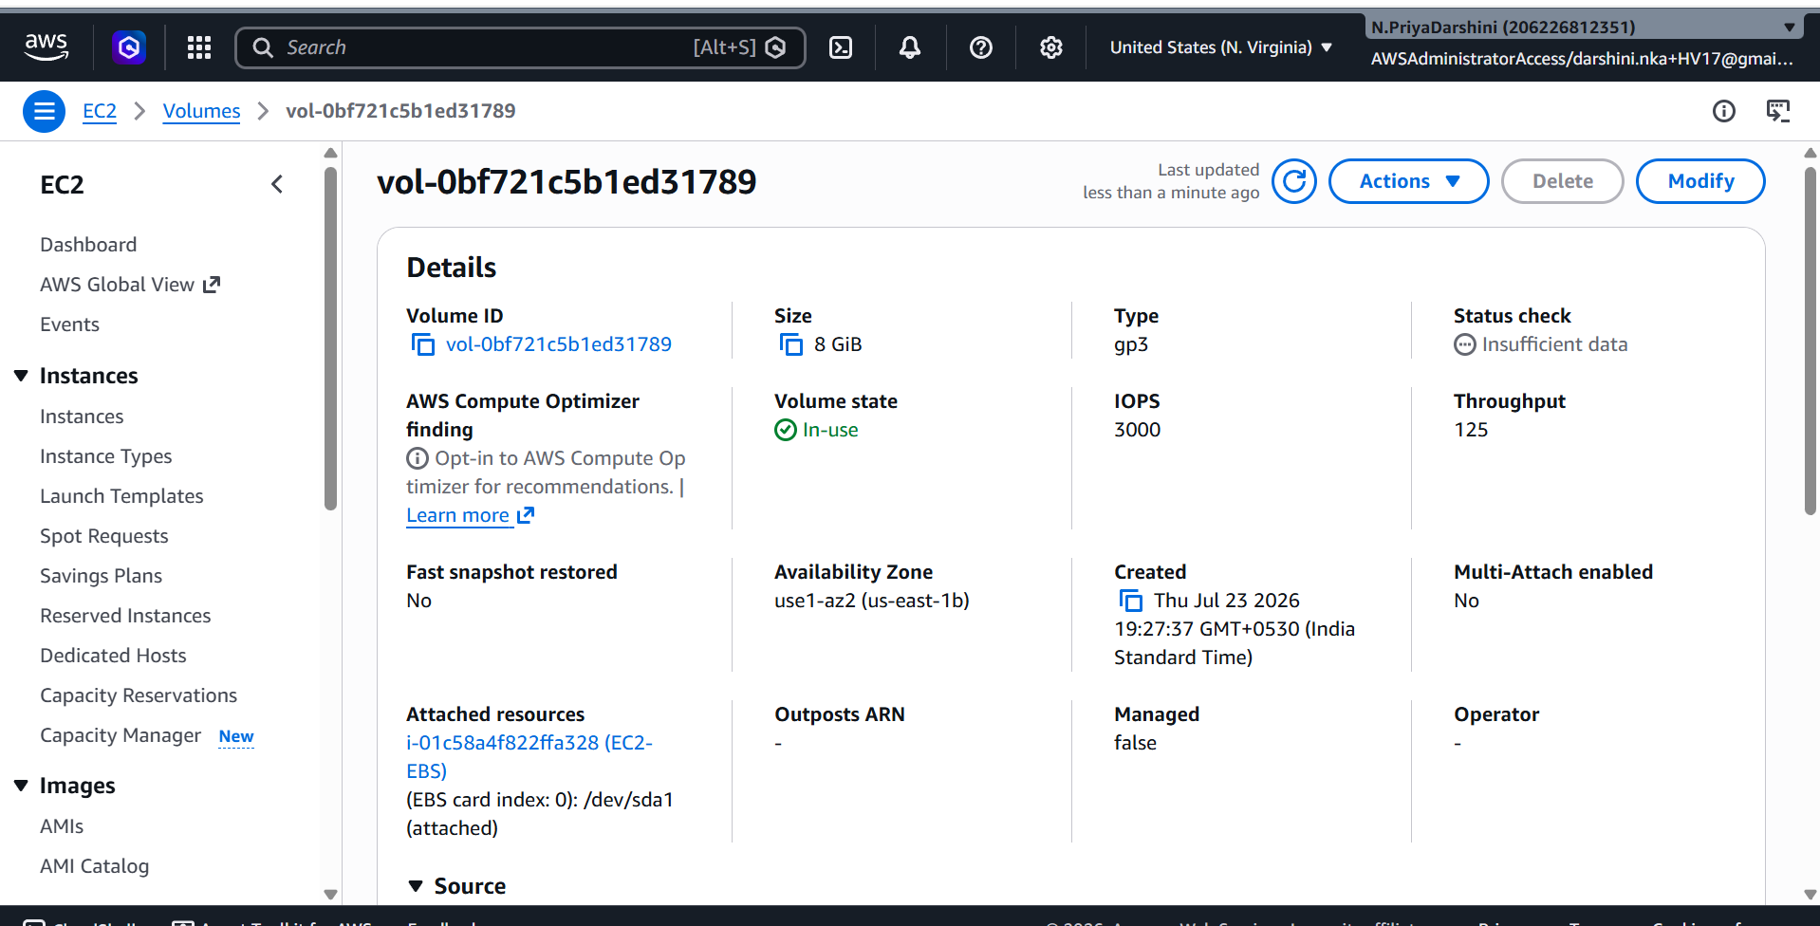
Step 2 – Verify a Snapshot Exists
Navigate to:
EC2
→ Snapshots
Confirm that at least one snapshot exists for the root volume.
Example:
snap-0ffe259ee34f7697a

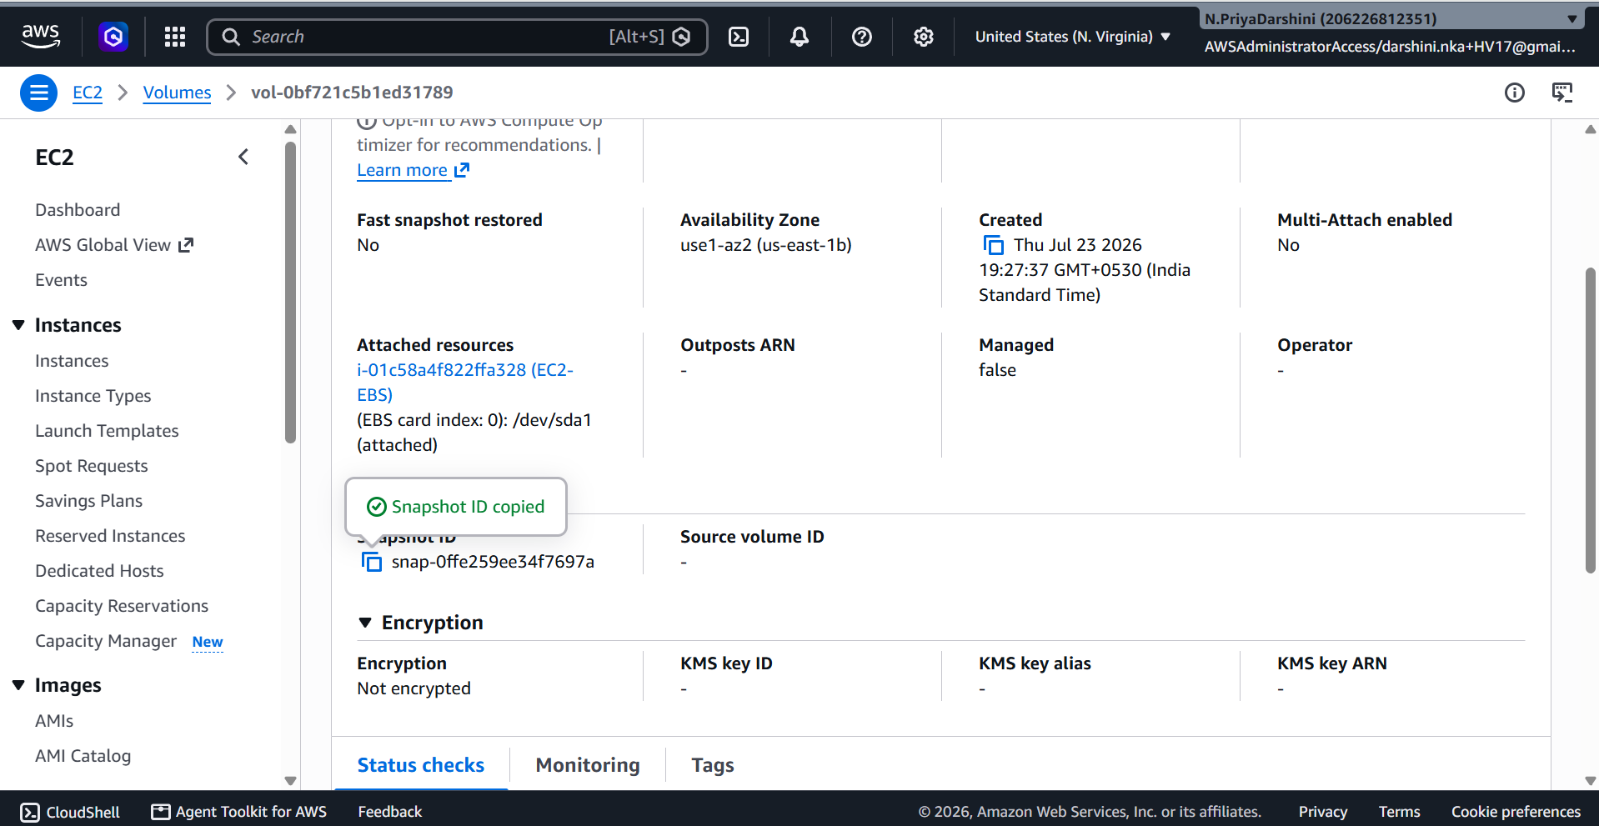
Step 3 – Create IAM Role for Lambda
Navigate to:
IAM
→ Roles
→ Create Role
Choose:
- Trusted Entity: AWS Service
- Use Case: Lambda
Role Name:
EC2RestoreLambda

Step 4 – Attach CloudWatch Policy
Attach the managed policy:
AWSLambdaBasicExecutionRole
This allows Lambda to write logs to CloudWatch.

Step 5 – Add Inline IAM Policy
Go to:
Permissions
→ Add Inline Policy
→ JSON
Paste the following policy:
{
"Version": "2012-10-17",
"Statement": [
{
"Sid": "RestorePermissions",
"Effect": "Allow",
"Action": [
"ec2:DescribeSnapshots",
"ec2:RegisterImage",
"ec2:RunInstances",
"ec2:DescribeImages",
"ec2:CreateTags"
],
"Resource": "*"
}
]
}
Optional (Recommended): If your Lambda also needs to wait for the AMI to become available or discover instance configuration automatically, include:
- ec2:DescribeInstances
- ec2:DescribeVolumes
- ec2:DescribeSubnets
- ec2:DescribeSecurityGroups
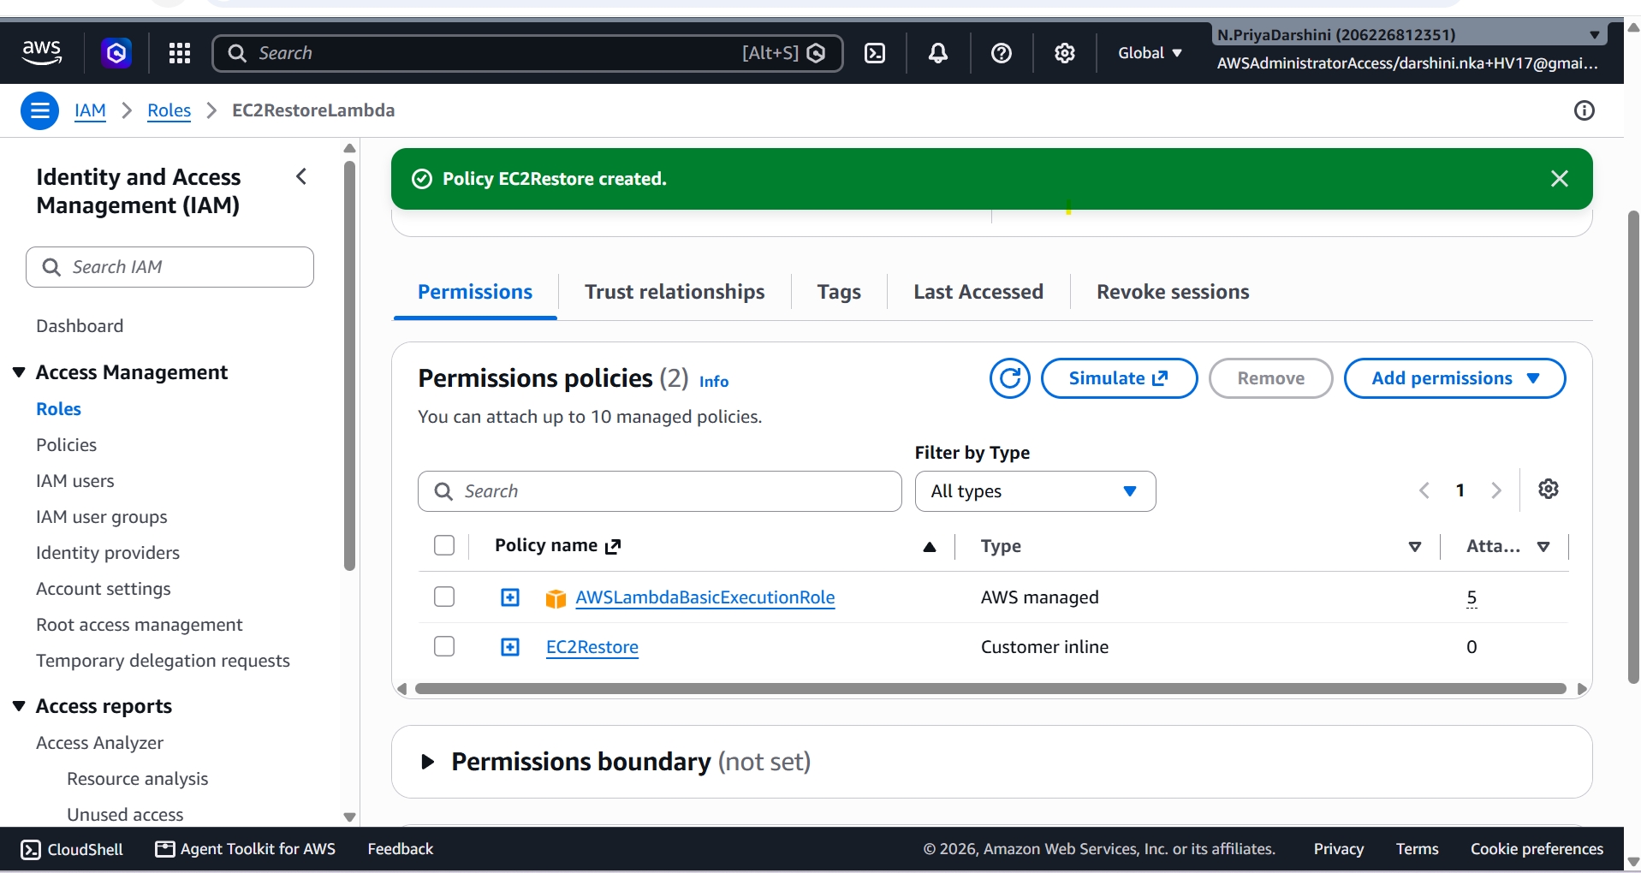

Step 6 – Create Lambda Function
Navigate to:
AWS Lambda
→ Create Function
Configuration:
Setting | Value
Function Name | EC2RestoreFromSnapshot
Runtime | Python 3.12
Execution Role | EC2RestoreLambdaRole
Click Create Function.

Step 7 – Configure Environment Variables (Recommended)
Instead of hardcoding values, add these Lambda environment variables:
Variable | Example
VOLUME_ID
SUBNET_ID | subnet-002b1c781ff8a1c4b
SECURITY_GROUP_ID | sg-0719cb8b09ce24243
KEY_NAME (optional) | priyamay17  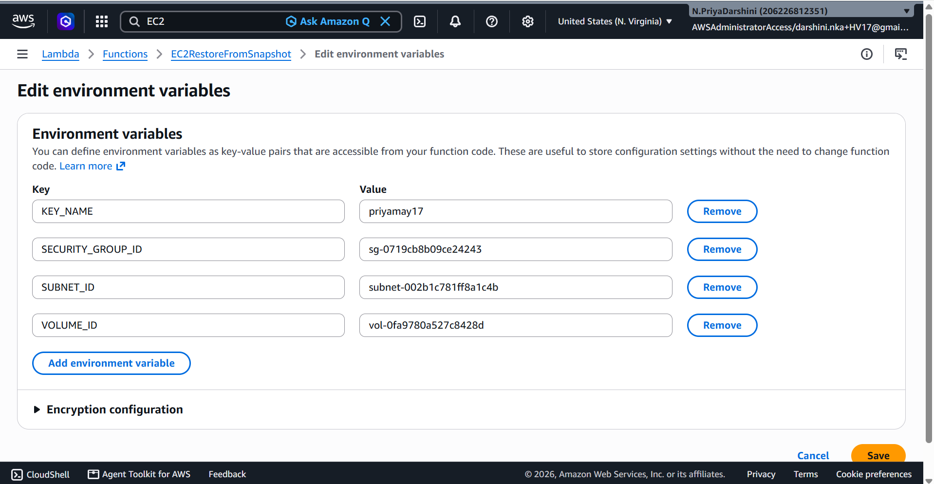

Step 8 – Lambda Python Code
import os
import time
import boto3

ec2 = boto3.client("ec2")

VOLUME_ID = os.environ["VOLUME_ID"]
SUBNET_ID = os.environ["SUBNET_ID"]
SECURITY_GROUP_ID = os.environ["SECURITY_GROUP_ID"]
KEY_NAME = os.environ.get("KEY_NAME")

def lambda_handler(event, context):

# Find latest snapshot
response = ec2.describe_snapshots(
Filters=[
{
"Name": "volume-id",
"Values": [VOLUME_ID]
}
],
OwnerIds=["self"]
)

snapshots = sorted(
response["Snapshots"],
key=lambda x: x["StartTime"],
reverse=True
)

if not snapshots:
raise Exception("No snapshots found.")

latest_snapshot = snapshots[0]

snapshot_id = latest_snapshot["SnapshotId"]

print(f"Latest Snapshot: {snapshot_id}")

ami_name = f"restore-{snapshot_id}"

# Register AMI
image = ec2.register_image(
Name=ami_name,
RootDeviceName="/dev/xvda",
BlockDeviceMappings=[
{
"DeviceName": "/dev/xvda",
"Ebs": {
"SnapshotId": snapshot_id,
"DeleteOnTermination": True,
"VolumeType": "gp3"
}
}
],
VirtualizationType="hvm",
Architecture="x86_64"
)

image_id = image["ImageId"]

print(f"AMI Created: {image_id}")

# Wait until the AMI becomes available
waiter = ec2.get_waiter("image_available")
waiter.wait(ImageIds=[image_id])

# Launch EC2 instance
run_args = {
"ImageId": image_id,
"InstanceType": "t3.micro",
"MinCount": 1,
"MaxCount": 1,
"SubnetId": SUBNET_ID,
"SecurityGroupIds": [SECURITY_GROUP_ID],
"TagSpecifications": [
{
"ResourceType": "instance",
"Tags": [
{
"Key": "RestoredFrom",
"Value": snapshot_id
}
]
}
]
}

if KEY_NAME:
run_args["KeyName"] = KEY_NAME

response = ec2.run_instances(**run_args)

instance_id = response["Instances"][0]["InstanceId"]

print(f"Restored Instance: {instance_id}")

return {
"Snapshot": snapshot_id,
"AMI": image_id,
"Instance": instance_id
}

Step 9 – Deploy the Lambda
Click Deploy.

Step 10 – Create a Test Event
Create a test event:
{}

Step 11 – Manual Testing
- Click Test to invoke the Lambda.
- Verify in the EC2 console that:
  - A new AMI is created.
  - The AMI reaches the Available state.
  - A new t3.micro instance is launched.
- Confirm the new instance has the tag:

Step 12 – Verify the Restored Instance
- Wait until the instance status checks pass.
- Connect using EC2 Instance Connect or SSH (if a key pair was provided).
- Verify that the root volume contains the expected data from the snapshot.

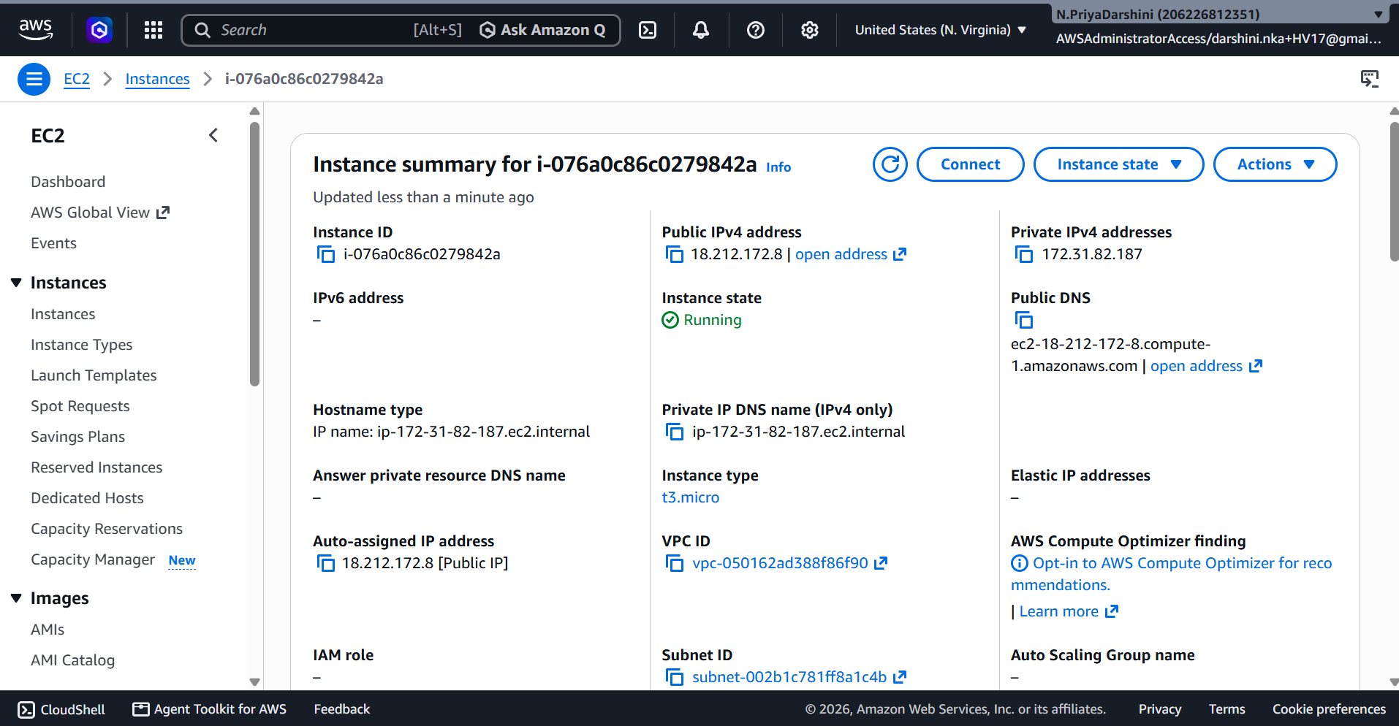

Step 13 – View CloudWatch Logs
Open:
CloudWatch
→ Log Groups
→ /aws/lambda/EC2RestoreFromSnapshot
Example log:
Latest Snapshot: snap-0abc123456789def0
AMI Created: ami-0123456789abcdef0
Restored Instance: i-0123456789abcdef0

Step 14 – Clean Up
To avoid unnecessary charges:
- Terminate the restored EC2 instance after testing.
- Deregister the temporary AMI if it is no longer needed.
- Delete any temporary snapshots that are no longer required.

Expected Lambda Response
{
"Snapshot": "snap-0abc123456789def0",
"AMI": "ami-0123456789abcdef0",
"Instance": "i-0123456789abcdef0"
}

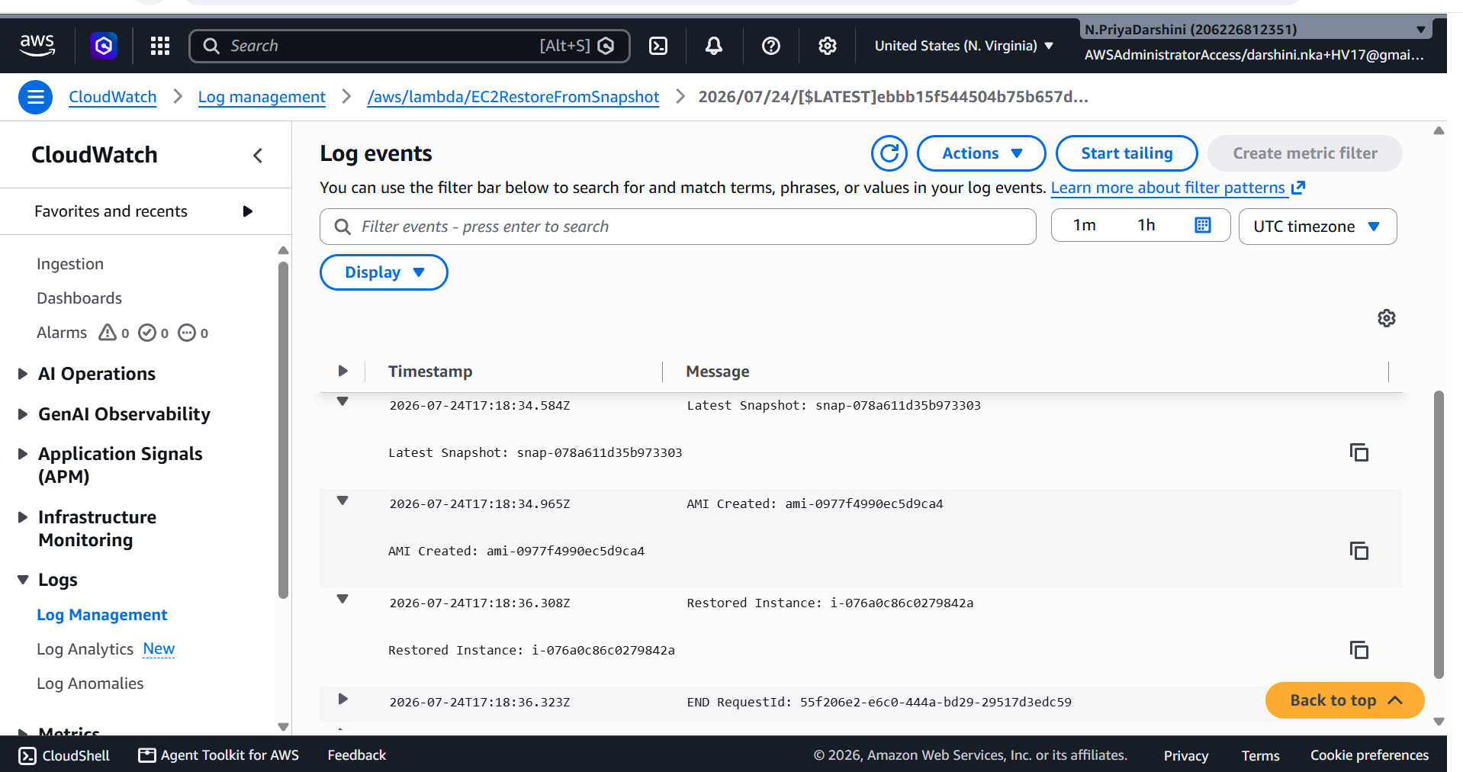

IAM Permissions Used
Permission | Purpose
ec2:DescribeSnapshots | Find available snapshots
ec2:RegisterImage | Create an AMI from the snapshot
ec2:DescribeImages | Check AMI status
ec2:RunInstances | Launch the restored instance
ec2:CreateTags | Tag the new instance
AWSLambdaBasicExecutionRole | Write logs to CloudWatch

Best Practices
- Use environment variables for the volume ID, subnet ID, security group ID, and optional key pair.
- Wait for the AMI to become Available before launching the instance (using the built-in waiter).
- Add try/except blocks and structured logging for production environments.
- Encrypt snapshots and AMIs if the source volume is encrypted.
- Consider using AWS Systems Manager Session Manager instead of SSH for administrative access.

Discussion Point (Interview Answer)
This Lambda-based workflow is useful when disaster recovery requires custom automation, such as restoring the latest backup on demand, selecting snapshots based on tags or business rules, or integrating with notifications, ticketing systems, or approval workflows.
For enterprise-scale disaster recovery across Regions or accounts, services such as AWS Elastic Disaster Recovery (AWS DRS) or managed backup solutions may provide more comprehensive orchestration, replication, and recovery capabilities.

